Voting result for oral amendment submitted by the United States to section G in document A/C.5/75/L.15
December 30, 2020
http://webtv.un.org/search/part-1-fifth-committee-8th-meeting-general-assembly-75th-session/6219371980001/?term=2020-12-30
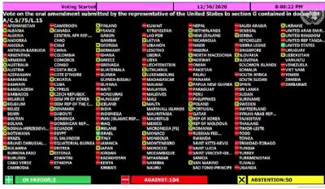
Vote total: 2 in favor, 105 against, 50 abstentions
In favor:
Israel, United States

Abstentions:
Albania, Andorra, Armenia, Australia, Austria, Belgium, Bosnia and Herzegovina, Botswana, Bulgaria, Canada, Croatia, Cyprus, Czechia, Denmark, Estonia, Finland, France, Georgia, Germany, Greece, Hungary, Iceland, Ireland, Italy, Japan, Latvia, Lithuania, Luxembourg, Malta, Monaco, Montenegro, Netherlands, New Zealand, North Macedonia, Norway, Papua New Guinea, Poland, Portugal, Republic of Korea, Republic Of Moldova, Romania, San Marino, Serbia, Slovakia, Slovenia, Spain, Sweden, Ukraine, United Kingdom, Uzbekistan

Against:
Afghanistan, Algeria, Angola, Argentina, Azerbaijan, Bahamas, Bahrain, Bangladesh, Barbados, Belarus, Belize, Bhutan, Bolivia, Brazil, Brunei Darussalam, Burundi, Cameroon, Chile, China, Colombia, Costa Rica, Cote d'Ivoire, Cuba, Democratic People's Republic of Korea, Democratic Republic Of The Congo, Djibouti, Dominican Republic, Ecuador, Egypt, El Salvador, Equatorial Guinea, Eritrea, Ethiopia, Ghana, Grenada, Guatemala, Guinea, Guyana, Haiti, Honduras, India, Indonesia, Iran, Iraq, Jamaica, Jordan, Kazakhstan, Kenya, Kuwait, Lao People's Democratic Republic, Lebanon, Lesotho, Libya, Liechtenstein, Madagascar, Malawi, Malaysia, Maldives, Mali, Mauritius, Mexico, Mongolia, Morocco, Mozambique, Myanmar, Namibia, Nepal, Nicaragua, Niger, Nigeria, Oman, Pakistan, Panama, Paraguay, Peru, Philippines, Qatar, Russian Federation, Saint Lucia, Saint Vincent And The Grenadines, Saudi Arabia, Senegal, Sierra Leone, Singapore, South Africa, Sri Lanka, Sudan, Suriname, Switzerland, Syrian Arab Republic, Tajikistan, Thailand, Timor-Leste, Togo, Trinidad and Tobago, Tunisia, Turkey, Uganda, United Arab Emirates, United Republic Of Tanzania, Uruguay, Venezuela, Viet Nam, Yemen, Zimbabwe

